Handheld
UPC Conversion
To convert a UPC-E (smaller, 8-digit UPC bar code) to a UPC-A (larger, 12-digit bar code) please scan the following bar code.
To revert back to UPC-E, scan the following bar code.
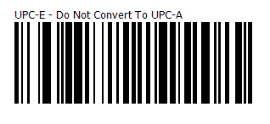
Note:
The conversion adds a leading zero to UPC-A decoded data format before transmission.
After conversion, the data follows UPC-A format and is affected by UPC-A programming selections (e.g., Preamble, Check Digit)

